# Wireshark Intro Lab

1. Three protocols captured are HTTP, TCP, SSL.

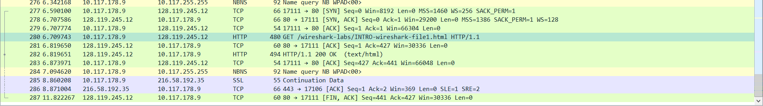

1. The time the HTTP request, GET to OK took 0.104011s.

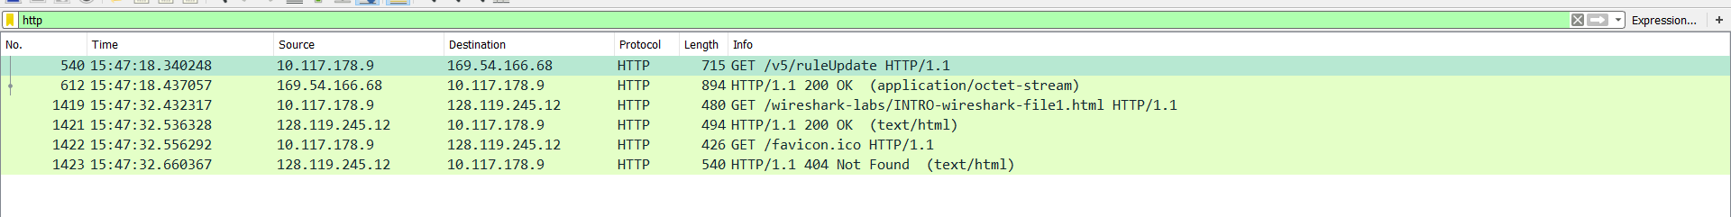

1. The IP address captured by Wireshark for the Gaia IP is 128.119.245.12. I had done the lab in the library, so the captured IP for my computer was 10.117.178.9.
2. Wireshark on Windows 10, has a known printer issue. I printed out to file, and copy pasted the contents here.  
   Bug Information: <https://www.wireshark.org/lists/wireshark-bugs/201601/msg00711.html>

## GET

No. Time Source Destination Protocol Length Info

1419 17.847950 10.117.178.9 128.119.245.12 HTTP 480 GET /wireshark-labs/INTRO-wireshark-file1.html HTTP/1.1

Frame 1419: 480 bytes on wire (3840 bits), 480 bytes captured (3840 bits) on interface 0

Ethernet II, Src: HonHaiPr_4e:3b:77 (48:e2:44:4e:3b:77), Dst: Alcatel-_c1:75:69 (e8:e7:32:c1:75:69)

Internet Protocol Version 4, Src: 10.117.178.9, Dst: 128.119.245.12

Transmission Control Protocol, Src Port: 17195 (17195), Dst Port: 80 (80), Seq: 1, Ack: 1, Len: 426

Hypertext Transfer Protocol

# OK

No. Time Source Destination Protocol Length Info

1421 17.951961 128.119.245.12 10.117.178.9 HTTP 494 HTTP/1.1 200 OK (text/html)

Frame 1421: 494 bytes on wire (3952 bits), 494 bytes captured (3952 bits) on interface 0

Ethernet II, Src: Alcatel-_c1:75:69 (e8:e7:32:c1:75:69), Dst: HonHaiPr_4e:3b:77 (48:e2:44:4e:3b:77)

Internet Protocol Version 4, Src: 128.119.245.12, Dst: 10.117.178.9

Transmission Control Protocol, Src Port: 80 (80), Dst Port: 17195 (17195), Seq: 1, Ack: 427, Len: 440

Hypertext Transfer Protocol

Line-based text data: text/html